- DECEMBER 2019  - Newsletter  Contact Us  Mailing Address:  P.O. Box 16461 Fresno, CA 93755  Phone: (559) 222-4824  Email:  thelight-house@sbcglobal.net  Web: www.lhrecovery.org  volunteer, serving six women in a sober living setting with a unique plan the Lord gave me. We were faithful and God grew us. There were many midnight hours, times with my face on the floor, but He always came through…and it was always through YOU! We still have contact with many of those first LadyBUGs and continue to see great outcomes. Why? Because while others call us a treatment service, we are actually a transformation center. People’s hearts are being transformed, permanently! The most recent ‘WOW’ is our transitional living complex. See little Wesley all snuggled in his new bed and bed set? Wesley is enjoying his new life with a healthy mom, which makes us ALL happy! Thank you to all who have been a part of this project. To the ones who purchased a $10 toaster to the one who gave $100,000.00 and everyone in between. Together, we’re changing people’s lives. This is definitely an ongoing project; if you’d like to be a part of the miracle, there are several different ways to get involved. From sponsoring a set of dishes to new windows or even offering to service the yard!  Podcast: www.angelsofthelight.info  Board of Directors  Larry Arce, Chairman  Martha Kistler, Vice Chair  Trish Pinedo, Secretary  Rebecca Nunes, Treasurer  Sandra Holland, Director  Tracy DeJong, Director  Tricia Miller, Director  Edmund Gil, Director  - Donations  - WE’VE MADE GIVING EASY!  Use the Google Pay app to give your gift. Just enter our email address and your gift will immediately transfer into our account with NO FEES.  OR  Follow these steps to our Wal-mart Registry  www.wal-mart.com  - Select Wal-Mart Services from menu  - Select Event registry  - Find a Registry:  Event: Lighthouse Where: CA  - Select: Lighthouse Housewarming | The Light-House Recovery Program, Inc.  WHILE I AM IN THE WORLD, I AM THE LIGHT OF THE WORLD. -JOHN 9:5  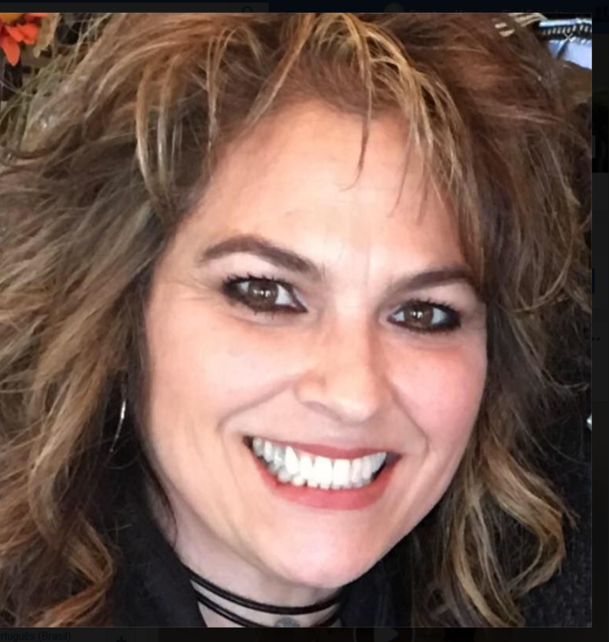  Looking back at 2019 causes my jaw to drop! The Lord and His people never cease to amaze me. I do my best to not get too familiar with His blessings, as they are in abundance, which can cause one to see amazing things as ordinary occurrences. He definitely keeps the ‘WOW’ factor before us. As a faith based organization, we depend on contributions from our neighbors, business people and churches. As we are approaching our 13th year of service and can honestly say that He, nor you have ever let us down. We started with myself and one other
- Mailing List  - We love keeping you up to  - date with the great life changes going on in the ministry however, if you would like to UNSUBSCRIBE, please use the self-addressed envelope to request your name  - be removed from our mailing list.  - Ongoing Needs  Toilet Paper (CASCADE BRAND) Don’t mean to be picky but with several women and old pipes, Cascade works best!  Copy paper (8 1/2x11)  With the purchase of our new 6 unit transitional housing complex, we are in need of stocking it with basic household supplies. If you would like to help with this, please do so through our gift registry!  Walmart.com Click Registry:  Lighthouse Housewarming  Business Partnership  We’re overwhelmed with appreciation! Thanks to Valley Produce, one of our units was completely furnished for it’s first Mother and child. Their love never stops! Also, to Valley Iron who sponsored the painting of five of our units and Fresno Painting for sponsoring one! Please be sure to do business with the businesses that are making a difference. | 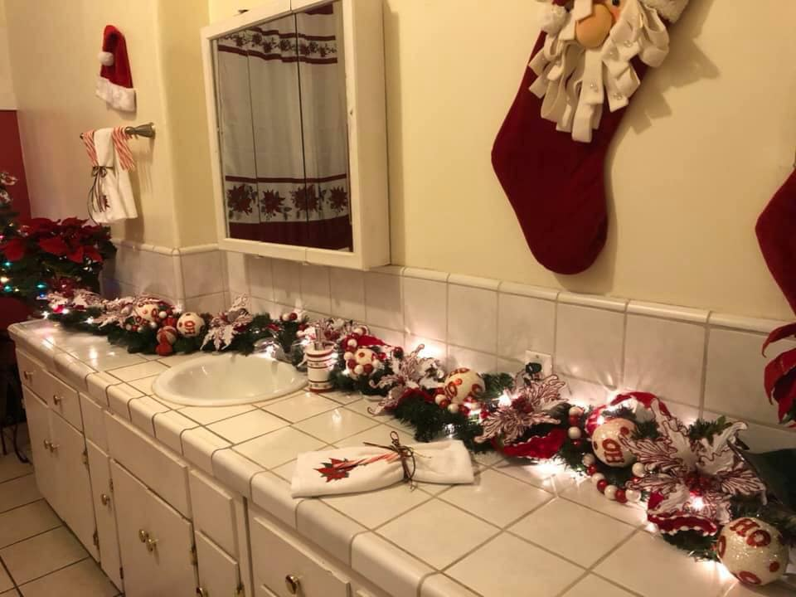  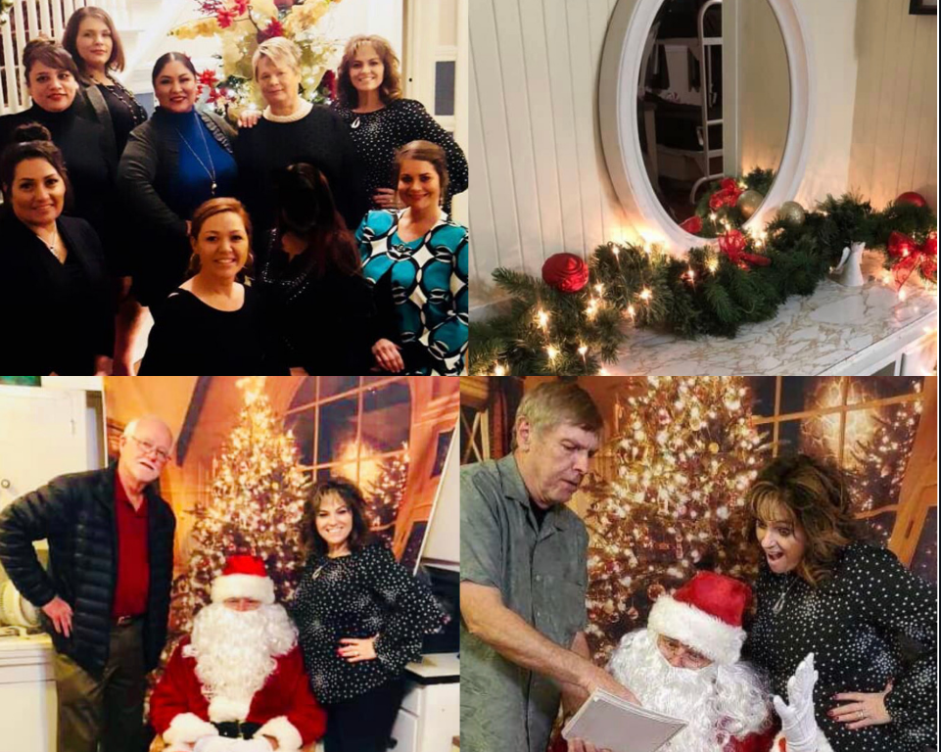  PREVIOUS EVENTS  Open House was a success, thanks to so many who sponsored rooms, brought goodies and came through. We enjoyed spiced apple cider while listening to master pianist, Brenda on the keyboard. Santa and his helper took pictures and gave out candy canes which was a hit. What touches my heart the most about this event is that the ladies we serve actually host as they take up a post in each room of the home and share with the guests what goes on in their home. It’s an opportunity to teach them public speaking, presentation ownership. They were so proud of themselves at the end of the night and will enjoy a fully decorated home all month long. Thank you for growing their confidence and visiting our home.  UPCOMING EVENTS  Soup for th Soul is just a month away. A great opportunity to wear your flannels, jeans and cozy up with sister friends, a variety of soups and listen to a fabulous speaker. Be sure to get your ticket quickly or help bring the fun by being a table hostess. Then, February is our GALentine tea. Call the office to reserve your spot, as this event is always SOLD OUT early.  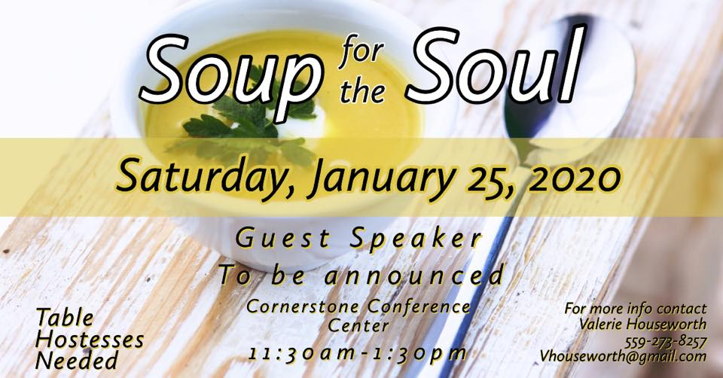  Galentine Tea Party  February 23, 2019

