- July 2019  - Newsletter  Contact Us  Mailing Address:  P.O. Box 16461 Fresno, CA 93755  Phone: (559) 222-4824  Email:  thelight-house@sbcglobal.net  Web: www.lhrecovery.org  Podcast: www.angelsofthelight.info  Board of Directors  Larry Arce, Chairman  Martha Kistler, Vice Chair  Trish Pinedo, Secretary  Rebecca Nunes, Treasurer  Sandra Holland, Director  Tracy DeJong, Director  Ron Killian, Director  Tricia Miller, Director  - Donations  WE’VE MADE GIVING EASY!  Either; log on to:  https://thelight-house.churchcenter.com/giving  to give your one time or re-occurring contributions.  OR  Use the Google Pay app to give your gift. Just enter our email address and your gift will immediately transfer into our account with NO FEES. | The Light-House Recovery Program, Inc.  WHILE I AM IN THE WORLD, I AM THE LIGHT OF THE WORLD. -JOHN 9:5  FREEDOM! This is the month our country celebrates independence. We honor our service men, shoot fireworks, BBQ, swim and and enjoy a care free day…all that Christ died for; abundant LIFE! Freely, He gave of himself for us. This is great love. His love. We can’t earn it, we can’t lose it. Unconditional love can be challenging. As parents, spouses and friends we have expectations and if not careful, might withhold the attributes of love when performance isn’t being met. Here at The Light-House, we remind ourselves that it is our job to minister the Gospel and teach practical application, while it’s His job to reveal Himself and set them free. This keeps us free in‘deed’.  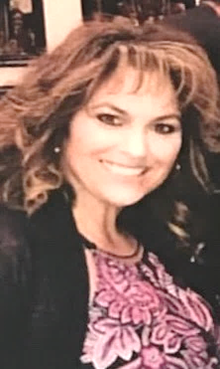  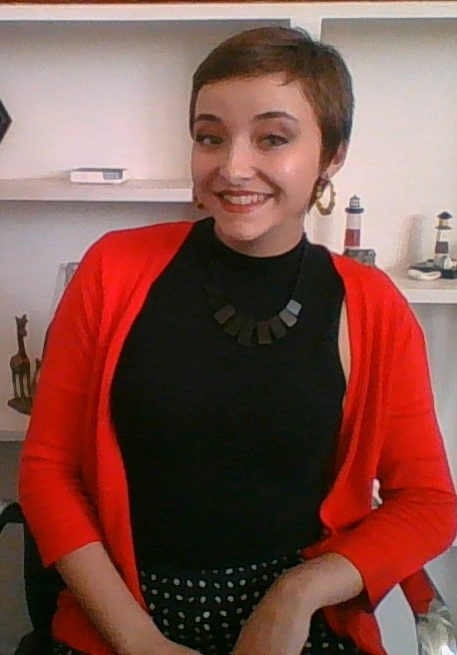  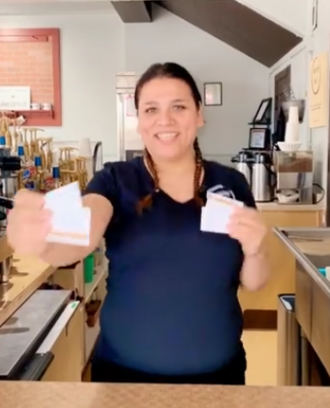  It’s almost here! We previously shared we’ll be having a beach day at the end of month. As Scripture promises, God is with us always, no matter where we go but, isn’t it just a little easier to feel and see Him and all of His majestic creation while walking the ocean’s shore?! Amazingly, some of our ladies have never been to the ocean. What a joy this will be! In addition to enjoying some care-free time, while their hair blows in the breeze, we’ll also grab a little clam chowder or a few fish tacos, talk about creation, why He created us, and just how unstoppable we are in Him. If you would like to be part of this awesome experience, we welcome your contribution to an experience that will last a lifetime.  She did it! Lauren, our baby LadyBUG has successfully completed the residential phase of our program. She continues to stay plugged in to the recovering community and with the aftercare and therapeutic components of our ministry. It is a privilege to continue serving her as she transitions out of our structured setting into living independently. She continues to manage employment, recovery, family reunification and her young life. Please keep Lauren lifted up in your prayers as she continues to develop in her purpose, gifts and calling.  Have you stopped in to grab your favorite cup of coffee lately? If not, you must come in and meet Annel! As our newest team members, she will always greet you with a smile. In addition to training all of the participants in our recovery program, we also provide training for mother’s dependent on public assistance. This has made such an impact, that currently, all our paid employees working the coffee shop were once dependent on public assistance. Since receiving training with us, they have become part of our paid team, no longer receiving cash aid. Wow! What a difference we’re making, literally moving moms from welfare to WORK!
- Mailing List  - We love keeping you up to  - date with the great life changes going on in the ministry however, if you would like to UNSUBSCRIBE, please use the self-addressed envelope to request your name be removed from our mailing list.  - Ongoing Needs  Women usually need a few more personal items than men and we know how important feeling and looking pretty matters. Our ladies need a few items to keep up with self-care, excellent hygiene and a dress for success look. Please peek at our wish list.  -make up, shampoo, har brushes  -body wash, feminine napkins  -toilet paper, bath towels  SMILE.AMAZON.com  Is online shopping your thing?  When shopping AMAZON smile.amazon.com, simply choose us as your non-profit (making sure to designate Fresno) and they will give a percentage of your purchase to us. It is that simple and free!  Business Partnership  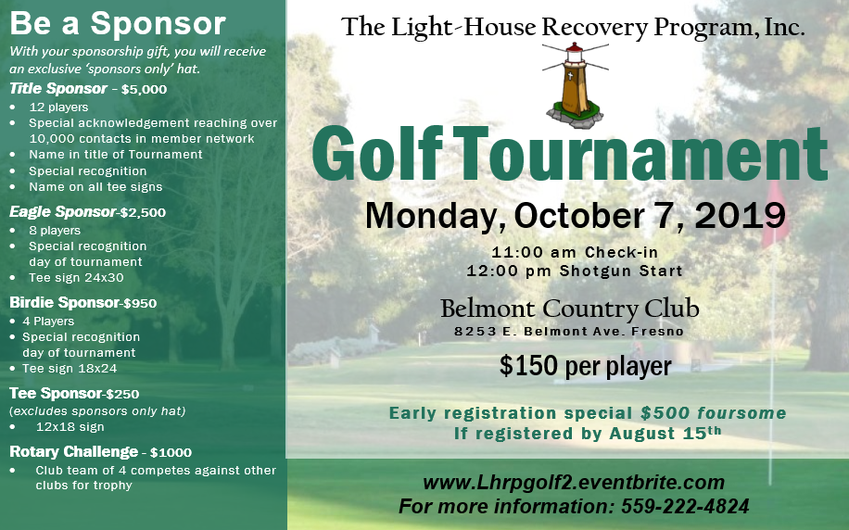  Thank you to our local business partners who so faithfully support the life changing work here at The Light-House. By choice, they faithfully designate a portion of their increase to offering healing to the women we serve. Not only are their dollars healing the women here, but also the children. What a blessing to be a blessing! | 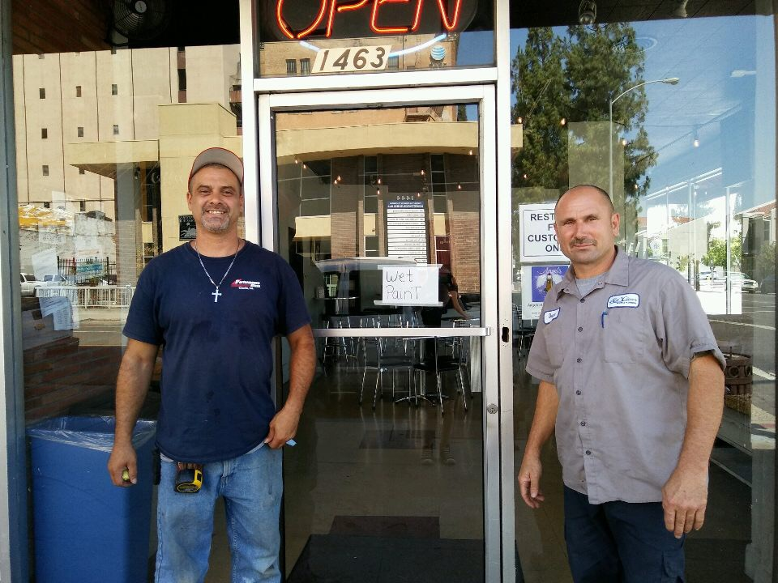  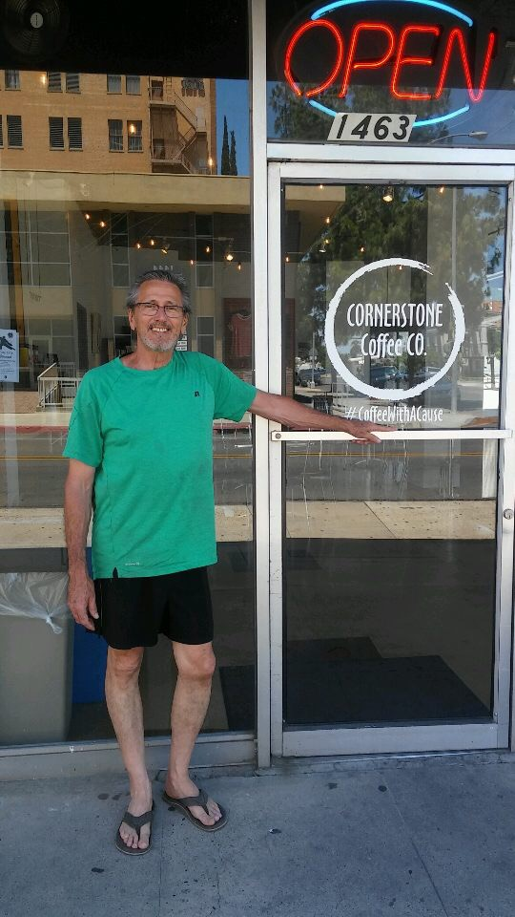  As we hit mid summer with our central valley heat, it appeared that we were also hit with a few extra challenges as well. First, our glass door to the coffee shop was vandalized and broken, later one of our toilets began to leak. In addition, our old blue van has no AC, which makes our trips to church and recovery meetings close to miserable….seemed like opposition on every side. However, I have found that when pressure approaches, even if God didn’t bring it, He will always use it! We’re so thankful for the local businesses who use their talent and treasure to be a blessing to our community. Kevin of Performance Glass ran to fill the need and replaced it at no charge! Later, Don of Donald Plumb Designs shows up and not only replaces our door logo, but took it a step further, creating a design for the large windows facing Stanislaus. We encourage you to take your business to those who help others. Let’s make it a win-win!  On Saturday, August 24th  Upcoming Events  Are you registered yet? You don’t want to miss our upcoming events. It will be a FUNdraising time!

