- MAY 2019  The Light-House Recovery Program  - Newsletter  Contact Us  Mailing Address:  P.O. Box 16461 Fresno, CA 93755  Phone: (559) 222-4824  Email:  thelighthouse@sbcglobal.net  Web: www.lhrecovery.org  Podcast: www.angelsofthelight.info  Board of Directors  Larry Arce, Chairman  Trish Pinedo, Secretary  Rebecca Nunes, Treasurer  Martha Kistler, Director  Sandra Holland, Director  Tracy DeJong, Director  Ron Killian, Director  - Donations  WE’VE MADE GIVING EASY!  Either; log on to:  https://thelight-house.churchcenter.com/giving  to give your one time or re-occurring contributions.  OR  Use the Google Pay app to give your gift. Just enter our email address and your gift will immediately transfer into our account with NO FEES. | WHILE I AM IN THE WORLD, I AM THE LIGHT OF THE WORLD. -JOHN 9:5  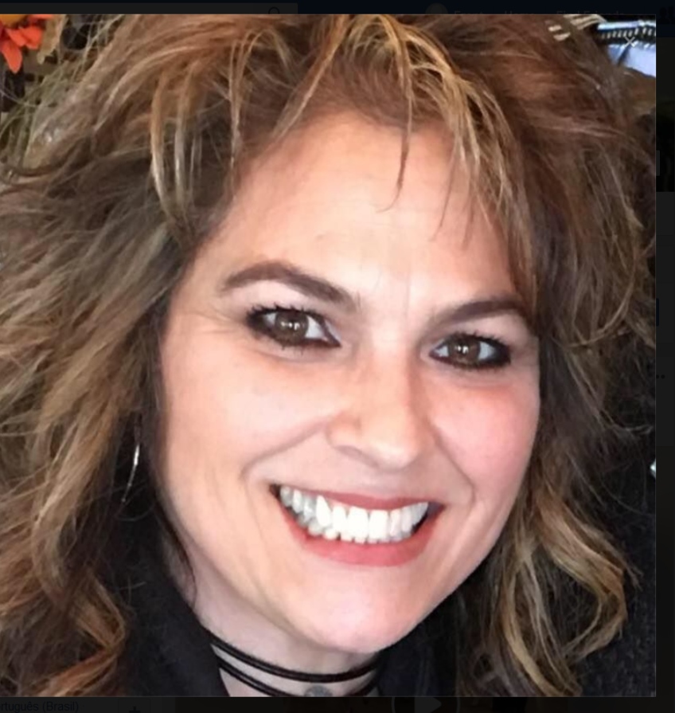  Like a Mother’s labor, the push is always worth the prize. Working with the ladies God directs to our door can be challenging to say the least however, watching those who are in it for the change, actually changing, transforming before your very eyes, all the ‘pushing’ proves worth it. God promises that our labor is not in vain, nor does His Word return void. It’s our business to reconcile, His to restore. I have found that He is quite faithful. We push them to the point of breathing on their own and then we watch Him grow them. What a sigt!  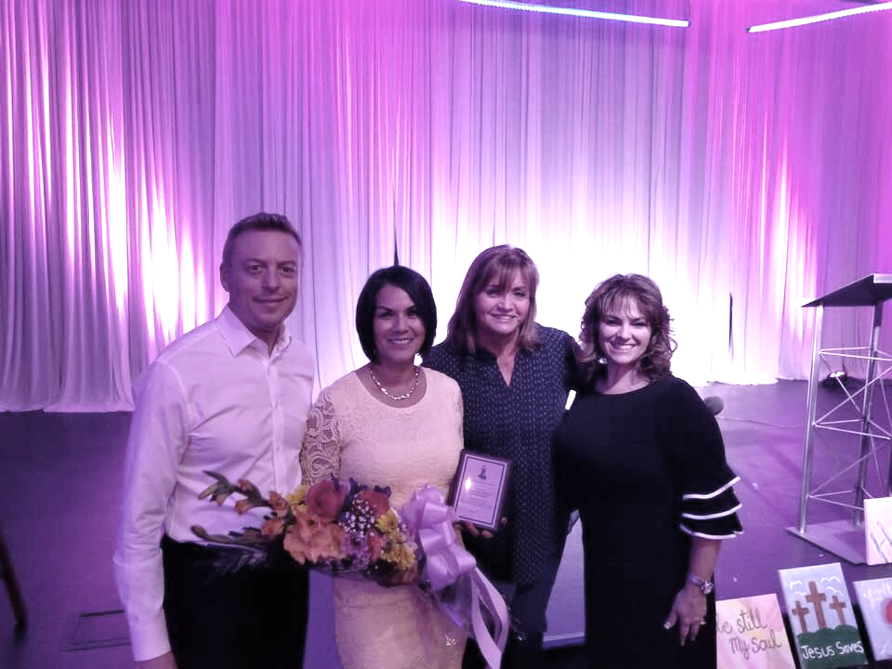  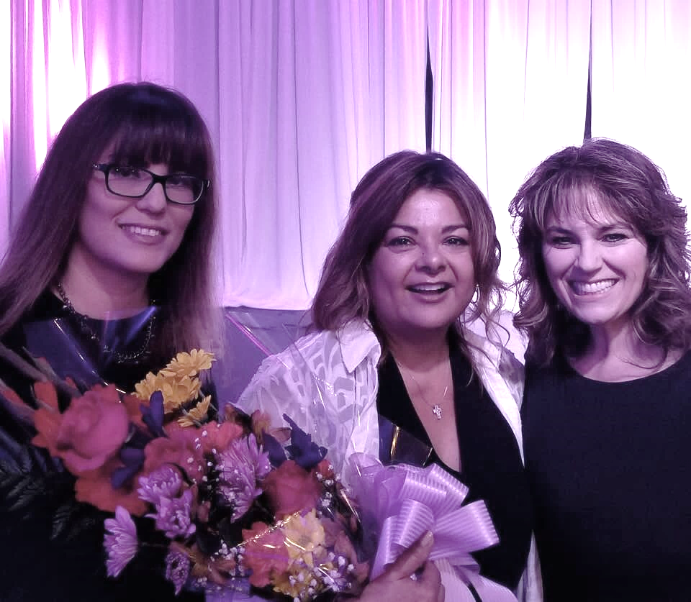  What an enlightening and encouraging word our Sheriff, Margaret Mims shared. Were you surprised in hearing that 90% of those incarcerated are substance abuse related? With the work we’re doing together at The Light-House, we’re able to decrease those numbers. Together, we’re changing individual lives and making an impact in reducing criminal activity in our city. Safety. Security. Sobriety.  Valerie Houseworth was honored as this year’s Volunteer of the Year. She selflessly gives in all areas of her time, talent and treasure every single month. Valerie never stops sharing about the miracles that go on at The Light-House, helping us to gain more support. She is one who helps us to shine throughout our city. We thank her and her family for all the love they offer the women and children we serve. Thank you Valerie.  Todd & Linda Mitchell of Green Fin Realty have been such a support to our operations. It was a privilege to acknowledge them as Business Donor of the year. Each quarter the Mitchell’s donate a percentage of their income to support our mission. They understand that God blesses them so that they can bless others, and what a blessing they are! If you’re in the market to buy or sell your home, give them a call, knowing your business is also providing housing for others.  Vikki Luna, Founder/CEO
- Mailing List  - We love keeping you up to  - date with the great life changes going on in the ministry however, if you would like to UNSUBSCRIBE, please use the self-addressed envelope to request your name be removed from our mailing list.  - Ongoing Needs  One of our needs is STILL a 15- passenger van. One that is new or gently used and preferably white in color. This would provide reliable transportation and allow our ladies to travel in pride.  AMAZON!  Who doesn’t shop on Amazon? When shopping online at smile.amazon.com, simply choose us as your non-profit and they will give a percentage of your purchase to us. It is that simple and free!  Please note you must manually enter smile.amazon.com.  Business Partnership  We are so encouraged  by our partners. What a difference you make in meeting the financial needs of our ministry. We’re especially grateful to Rosa Losey of Health Markets. Rosa has supported our mission in several different ways over the years, most recently as a Presidential sponsor to our annual banquet. Please see Rosa for your insurance needs. | 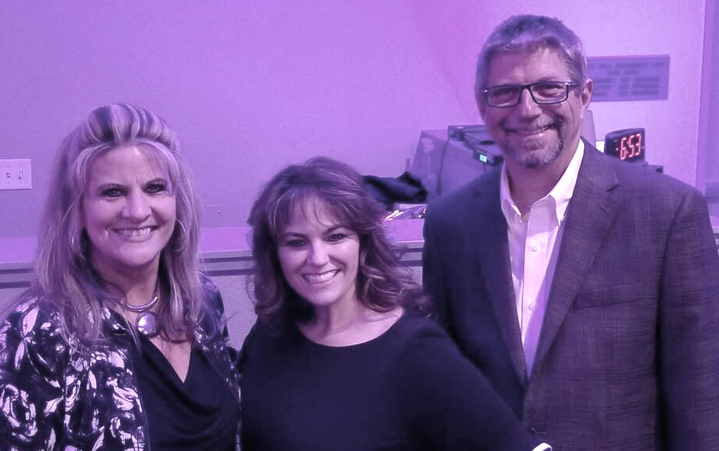  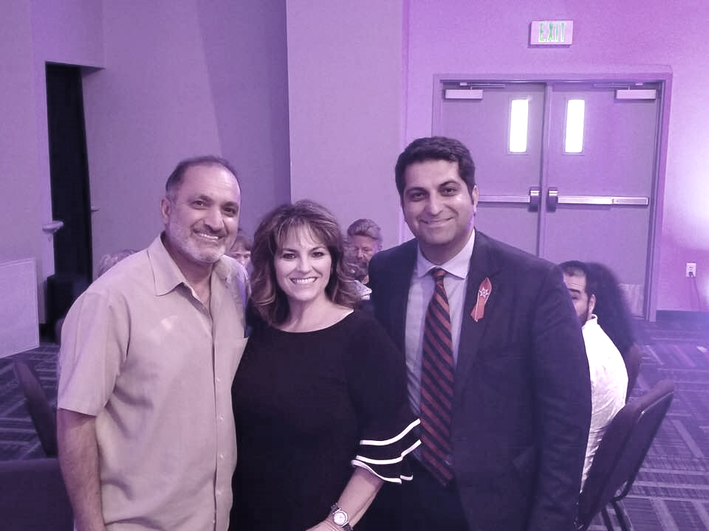  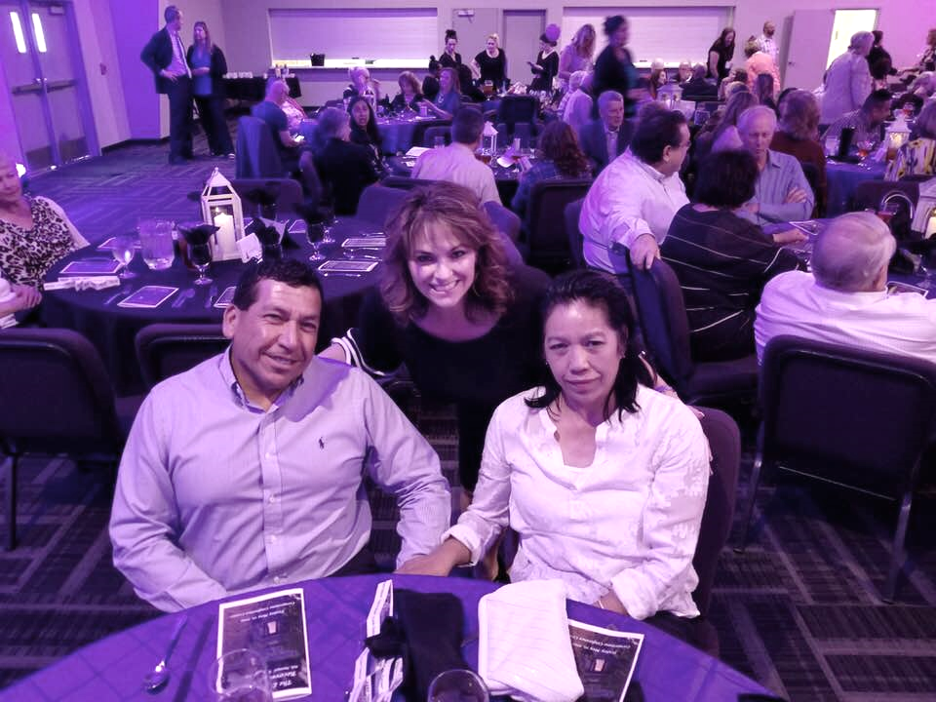  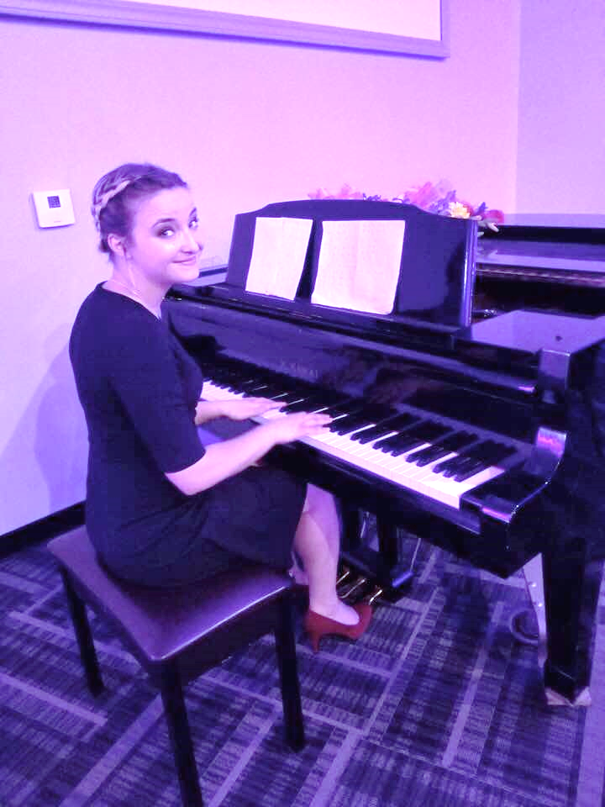  Oh what a night! Thank you to those of you who attended, sponsored, organized or helped our annual banquet to be the success that it was. Your contributions brought in more than the last two years combined! We are getting very close to negotiating for our transitional 4-plex and will begin shopping before the month is over. I hope you were delighted by the testimonies of healing that your support helps to make happen. What a difference God can make in the lives of others when we just say yes to supporting His work. You are the Light, You are the salt that the Lord is using to help these women, young and older to continue walking the pathway of recovery.  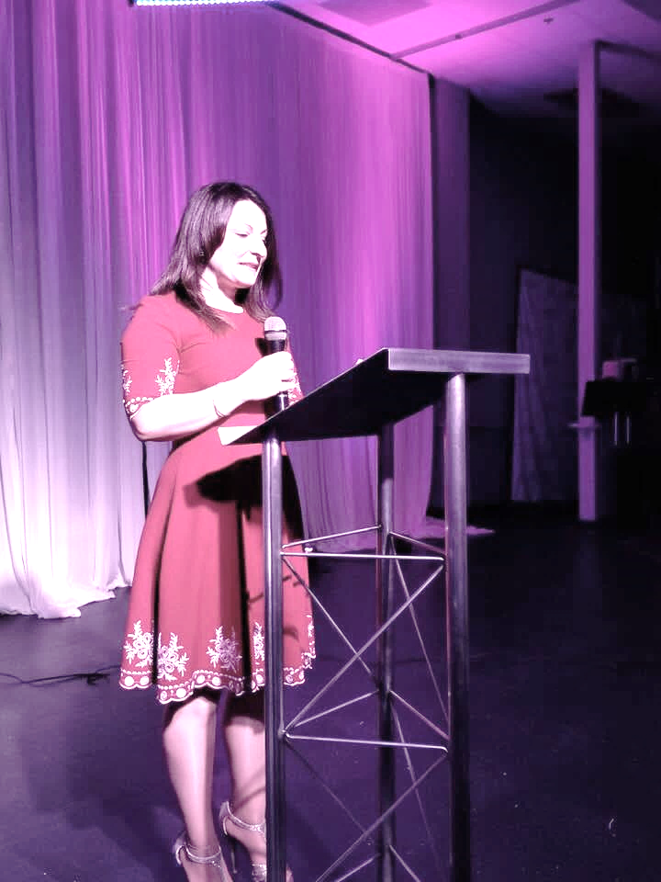  Upcoming Events  June is our annual Swim party and we’re hoping to add a trip to the beach. Some of our ladies have never been to the ocean. If you’d like to sponsor a LadyBUG, cost is only $40 each. Total expense is $520 for the group going.  October 7, 2019  Get ready for a day on the GREEN! Get your foursome registered early for the discount and if you are a Rotarian, get your club registered for the Rotary Challenge. Last year, Sunset Rotary ran off with the trophy and prizes! Which club will bring them a challenge this year?  August 24, 2019  Annual BUNCO FUNdraiser

