- SEPTEMBER 2019  - Newsletter  Contact Us  Mailing Address:  P.O. Box 16461 Fresno, CA 93755  Phone: (559) 222-4824  Email:  thelight-house@sbcglobal.net  Web: www.lhrecovery.org  Podcast: www.angelsofthelight.info  Board of Directors  Larry Arce, Chairman  Martha Kistler, Vice Chair  Trish Pinedo, Secretary  Rebecca Nunes, Treasurer  Sandra Holland, Director  Tracy DeJong, Director  Ron Killian, Director  Tricia Miller, Director  Edmund Gil, Director  - Donations  WE’VE MADE GIVING EASY!  Either; log on to:  https://thelight-house.churchcenter.com/giving  to give your one time or re-occurring contributions.  OR  Use the Google Pay app to give your gift. Just enter our email address and your gift will immediately transfer into our account with NO FEES. | The Light-House Recovery Program, Inc.  WHILE I AM IN THE WORLD, I AM THE LIGHT OF THE WORLD. -JOHN 9:5  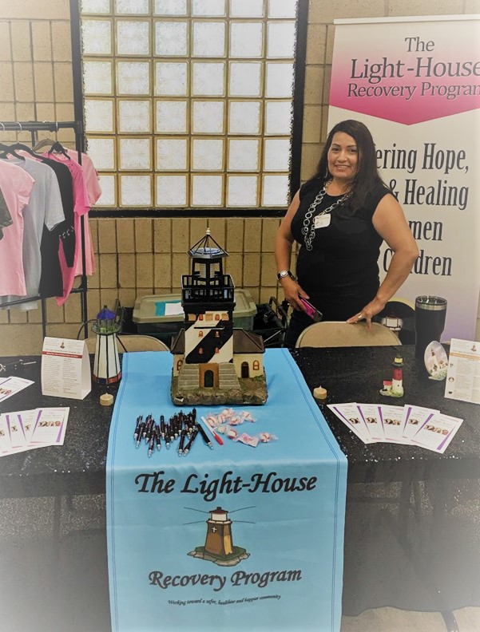  First impressions are important. Having Elsa greet each new lady as she embarks on a new path helps to ease her anxiety of the unknown. Having once been there herself, Elsa greets them with compassion and encouragement. She shares how God helped her, gave her a choice and she chose life. Today Elsa spends that new life serving! As assistant to our Director, she serves in every area of the ministry; whenever and wherever needed. She truly has a servant’s heart and matched with her many talents, is an asset to the operations of the entire ministry. We’re not only proud of how she continues to walk in the call God’s placed on her life, we’re priviledged to watch her grow and thankful He put her on our team!  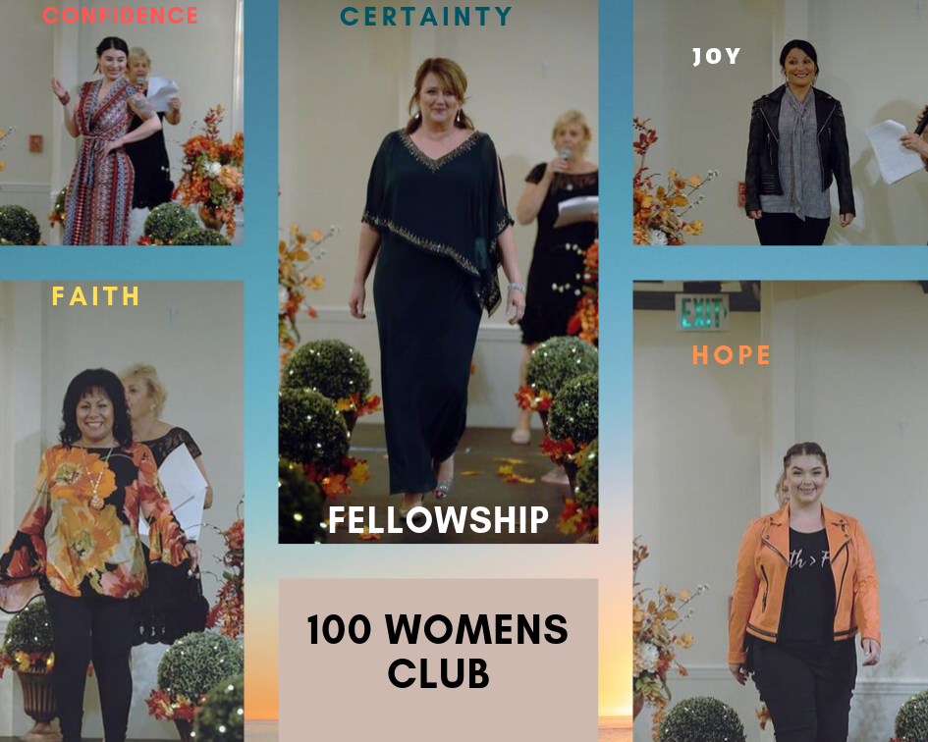  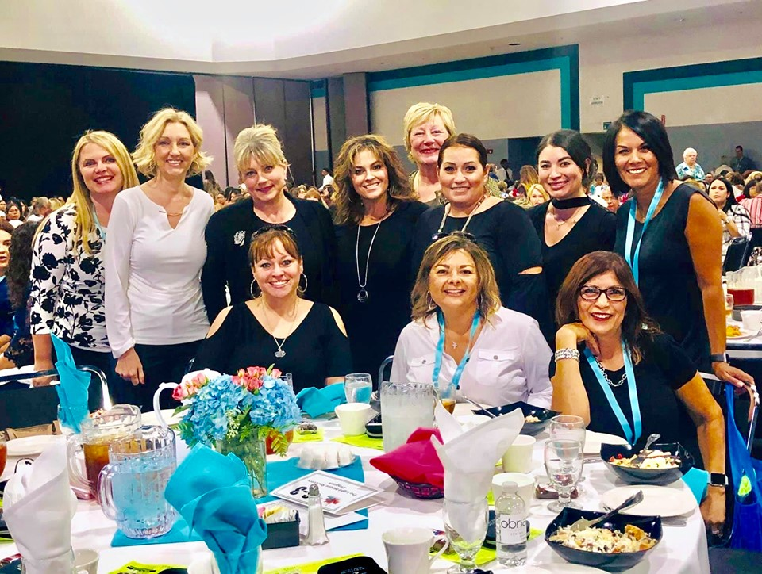  Our 1st annual 100 Women’s Club was a night to remember. Our alumni were able to ‘model’ their success in fashions found at Macy’s, SteinMart and our very own Light-WEAR line. A few of our donors modeled their example of how they use their business to support our mission and others modeled how our work training program moved them from dependency on public assistance to complete self-sustainability. It was a fabulous night with phenomenal friends celebrating many successes.  1ST ANNUAL 100 WOMENS CLUB  A few of our friends, staff, board of directors and donors gathered together for a day of empowerment at Central California Women’s Conference. Sharing with attendees as they visited our booth and selling close to all of our Light-WEAR inventory! Tyra Banks talked about how her Mother pushed her in to her purpose, something we do with our LadyBUGs.
- Mailing List  - We love keeping you up to  - date with the great life changes going on in the ministry however, if you would like to UNSUBSCRIBE, please use the self-addressed envelope to request your name  - be removed from our mailing list.  - Ongoing Needs  As we approach the change of season, it is time to change our linens. Items needed are:  dark colored twin sheet sets (preferably brown or blue)  -white bath towels  -dark blue or gray kitchen towels  -wash cloths (bath and kitchen)  -electric blankets (twin,new)  -dark brown twin comforters  SMILE.AMAZON.com  Is online shopping your thing?  When shopping AMAZON smile.amazon.com, simply choose us as your non-profit and they will give a percentage of your purchase to us. It is that simple and free!  Business Partnership  Thank you to our local business partners who so faithfully support the life changing work here at The Light-House. This year, Granville Homes is a sponsor of our annual LadyBUG recovery conference.  They have faithfully used their increase to take care of the  women and children in our city. God flows to those He can flow through!  What a blessing to be a blessing! | 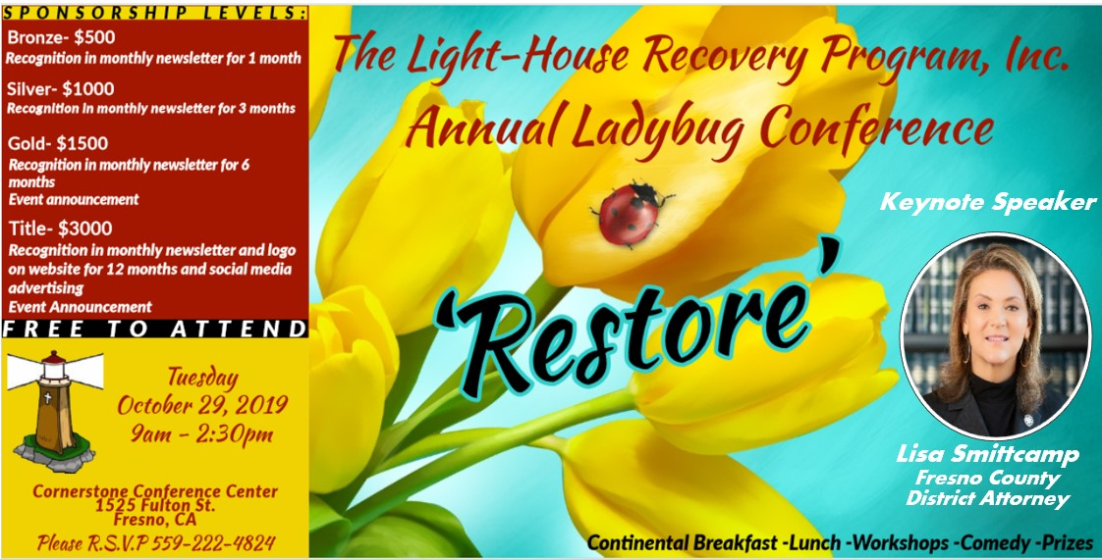  UPCOMING EVENTS  There is always something happening at The Light-House. If you’re looking for ways to make an impact in the lives of others, we welcome you to join us in all the fun and exciting ways to be involved. Please go to our website or call our office for up to date info on our events and volunteer opportunities. Soon coming is our annual LadyBUG Recovery Conference where 100 recovering women in our city will receive a day of education and workshops. Be a key player by supporting with your business or individual sponsorship. It’s a rewarding way to make a difference.  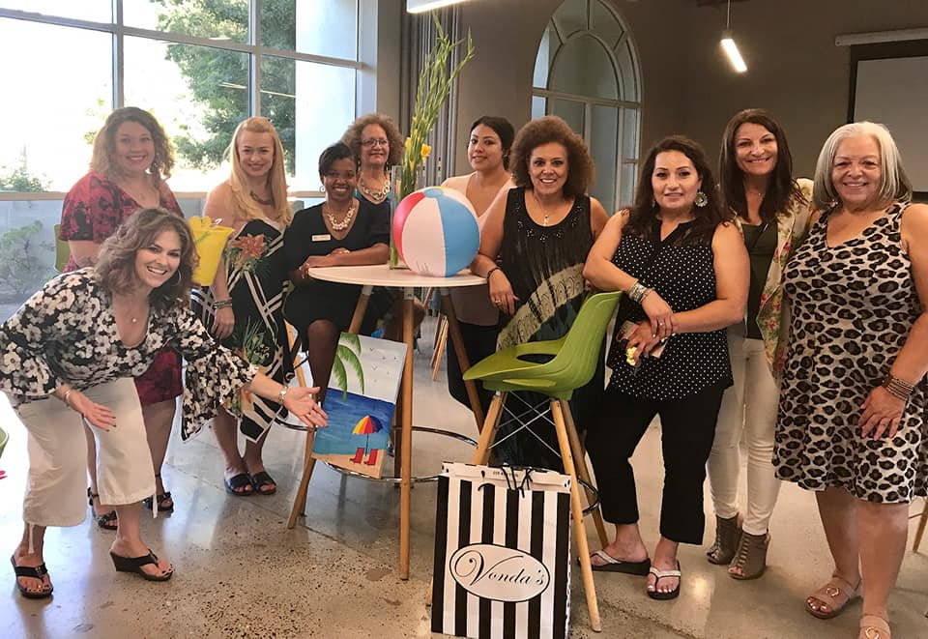  Our 3rd Annual Bunco Bonanza was a blast! So much laughter filled the room. As ladies travel from table to table, new friendships and smiles are formed. Alice Green and her team work hard behind the scenes to make it a meaningful and memorable event. Women helping women is the goal of this event; helping each other feel the effects of friendship, live in love and move the mission of The Light-House. It’s a great way to build relationships while building self and taking care of the underserved in our city at the same time. Catch us next year, we’ll show you how to ‘roll’.

