- JUNE 2019  - Newsletter  Contact Us  Mailing Address:  P.O. Box 16461 Fresno, CA 93755  Phone: (559) 222-4824  Email:  thelighthouse@sbcglobal.net  Web: www.lhrecovery.org  Podcast: www.angelsofthelight.info  Board of Directors  Larry Arce, Chairman  Trish Pinedo, Secretary  Rebecca Nunes, Treasurer  Martha Kistler, Director  Sandra Holland, Director  Tracy DeJong, Director  Ron Killian, Director  - Donations  WE’VE MADE GIVING EASY!  Either; log on to:  https://thelight-house.churchcenter.com/giving  to give your one time or re-occurring contributions.  OR  Use the Google Pay app to give your gift. Just enter our email address and your gift will immediately transfer into our account with NO FEES. | The Light-House Recovery Program, Inc.  WHILE I AM IN THE WORLD, I AM THE LIGHT OF THE WORLD. -JOHN 9:5  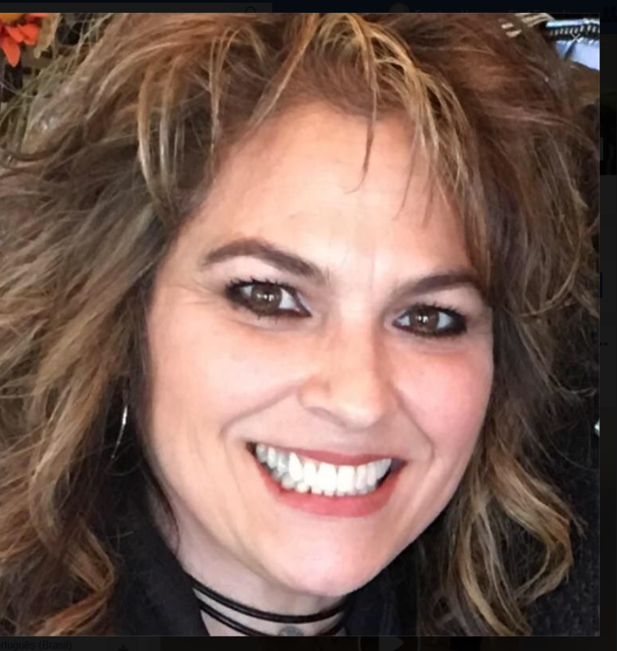  We will soon be house hunting! Our 4 plex is waiting for our occupancy and our women and children can hardly wait! A real home, not a bedroom, will be offered to our graduates at a subsidized price to assist them in reunifying with their families and to continue supporting their efforts toward self sustainability. It was just one short year ago that you helped in securing the residential home on L street and thanks to you, here we ‘GROW’ again! Romans 10 shares that the workers laboring in love can not preach the good news of the gospel unless they are sent. Thank you for sending us each day with your love and support.  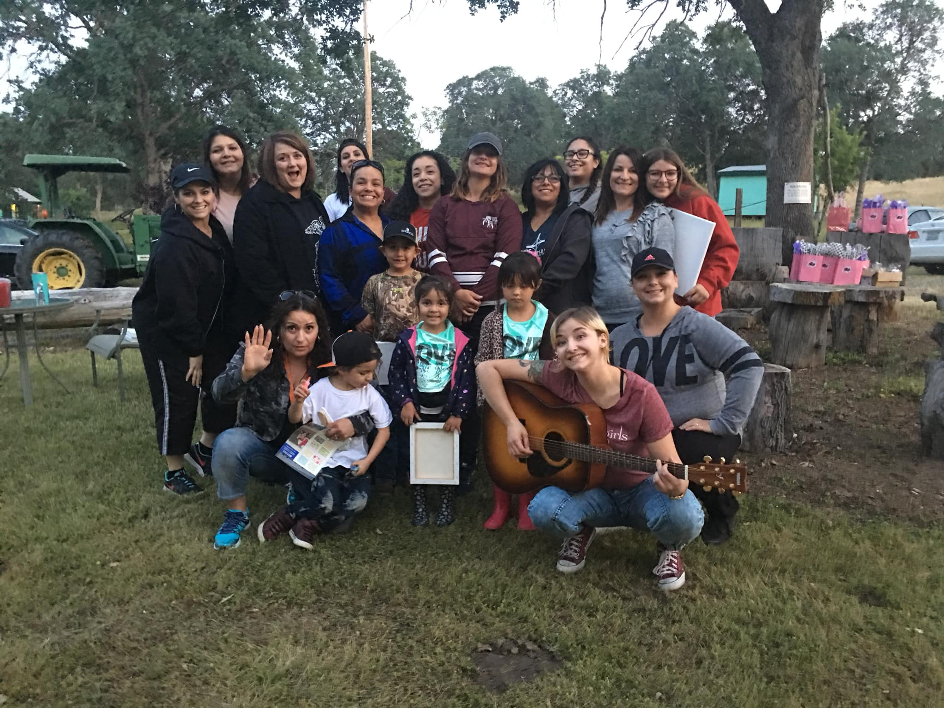  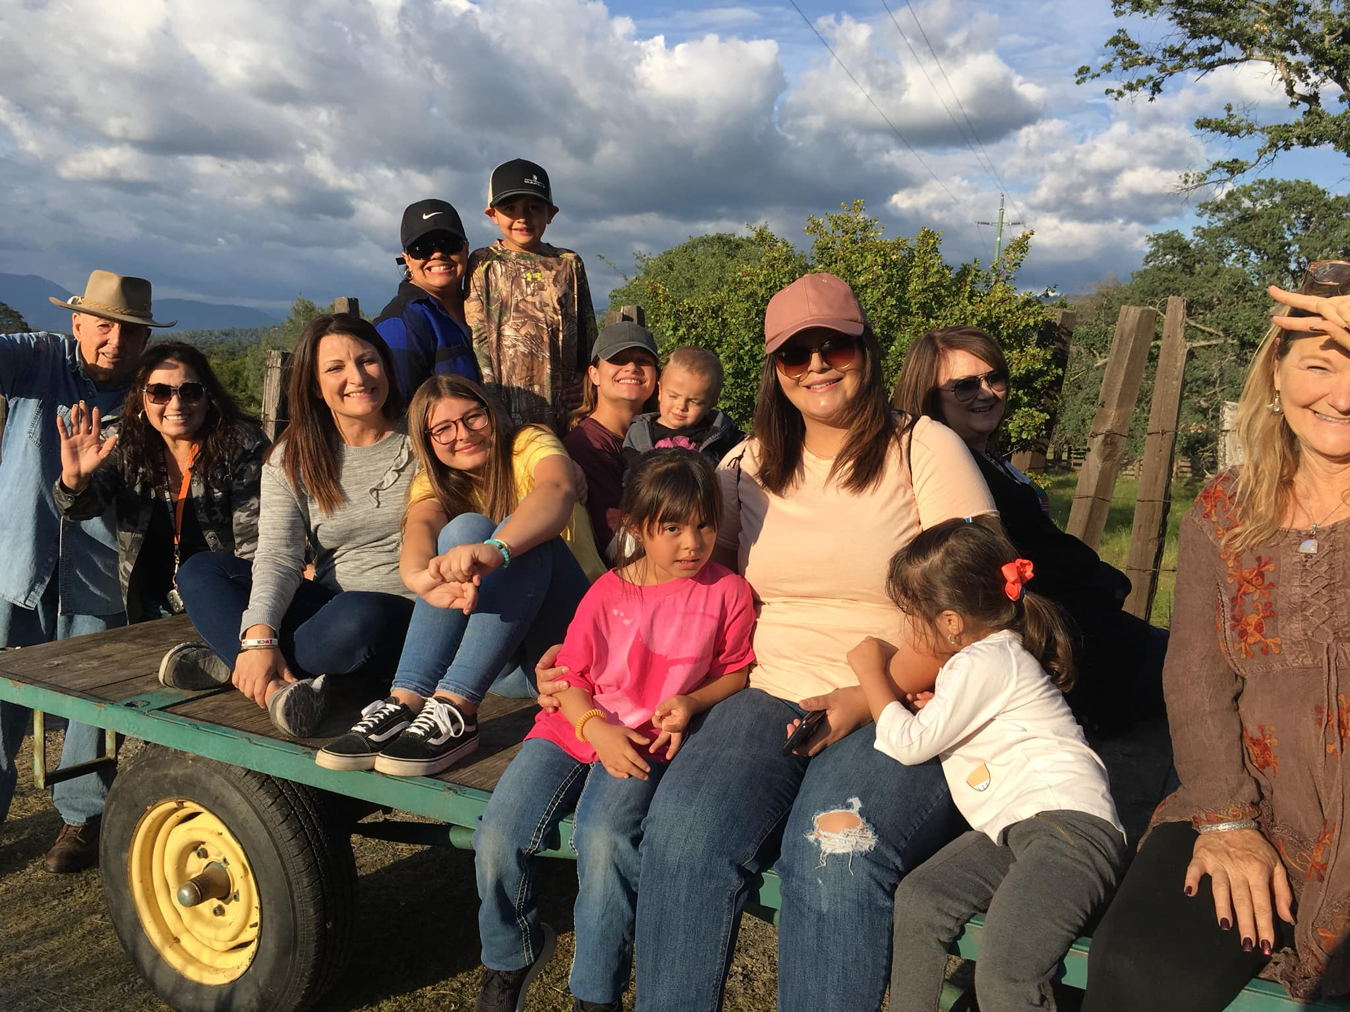  Keep your eyes open next month, as we will be taking the residential ladies to the beach and inviting the alumni to join us. Surprisingly, some of our women have never walked the sands or swam the ocean. It will be a wonderful day trip and the ladies will also experience a self- love and forgiveness activity of learning how God tosses our sins into the sea of forgetfulness, no longer holding them against us. Thank you to Lorene and Janie who have already sent in their donations contributing to the resources needed for this trip. What a glorious day this will be.  We have an awesome alumni group that meets monthly led by Renea a graduate of our program in 2012. Renea enjoys coordinating the monthly meetings and always adds a little extra love with her creativity. In May, the group met in the foothills for an overnight camp out. They enjoyed wagon rides, God talks as they walked along the trails and ponds and great cooking. Friday night they enjoyed art therapy out in the open air with their children led by Elsa, our staff who has a heart for the women we serve. Later, music and sing-a-longs by the campfire. Saturday was greeted with games, laughter and lots of love.  One of the alumni recognized all the vehicles parked along the road and was able to contribute the groups monetary gains to the provision of God and their continued commitment to self -sustainability through employment. It is always a blessing to see that the seeds planted, and the foundation laid while they were with us continue to be strong and stable. In addition to all of their fun, the children were able to enjoy the retreat as well. With great appreciation to Marina, our team member who rose early to direct the children’s activities. Thank you to Gus, Bonnie and all of you who continue to water the seed.
- Mailing List  - We love keeping you up to  - date with the great life changes going on in the ministry however, if you would like to UNSUBSCRIBE, please use the self-addressed envelope to request your name be removed from our mailing list.  - Ongoing Needs  Costco toilet paper, coffee grounds, cleaning products and school supplies are always needed. We appreciate your generosity.  AMAZON!  Is online shopping your thing? When shopping online at smile.amazon.com, simply choose us as your non-profit and they will give a percentage of your purchase to us. It is that simple and free!  Please note you must manually enter smile.amazon.com.  Church Partnership  Thank you to our local church partners who so faithfully support the life changing work here at The Light-House. They continue to help transform lives outside the church walls by financially supporting the education, therapy and nurturing provided to the women within our walls. Is your home church a seed planting partner with us? We’d love for you to introduce us to your Pastor, Women’s or Mission’s director so we can share all of what God’s doing. Will you link us? | 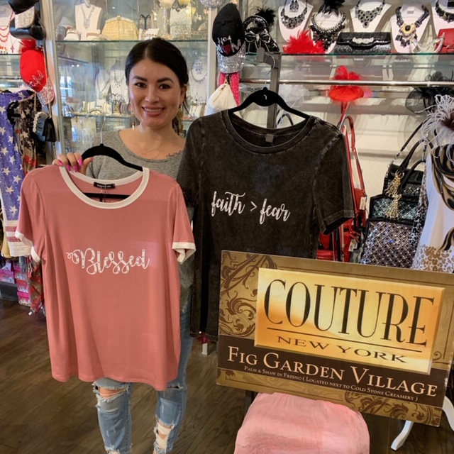  Have you heard? Our Light-WEAR line, created by our LadyBUGS is now being carried in Fig Garden Village, selling at Couture New York! It’s the cutest little boutique carrying unique items where our merchadise fits in perfectly. Please stop by and support them as they support our underserved women in their efforts and commitment to learning entrepreneur skills. #Light-WEAR  Upcoming Events  Mark your calendars, GUYS & GALS! We have several activities lined up to provide fun, friendship and philanthropic opportunities. We are grateful for the men and women in our community who take their hobbies and turn them in to generosity toward our mission. Join in on one of the upcoming activities- you’ll be sure to have a great time.  Ladies, you won’t want to miss this BUNCO. It’s easy and no experience is necessary! And Golfers…get out the clubs for a fun day on the green. If you’re not a golfer, we welcome you to sponsor the event with your business name. If you are interested in participating and/or sponsoring any of these upcoming events, please call our office for more details.  ANNUAL BANQUET UPDATE: Final numbers are still to be determined as we continue to have gifts come in but one thing’s for sure; you delivered more support than the last two years combined making the matched donation and purchase of the 4 plex possible. Stay tuned for an update on the purchase of our transitional complex and be sure to attend the ribbon cutting ceremony.  UPDATE: If you’ve been keeping up with the progress of our ladies, I’m excited to share with you that last week I had the privilege of taking Coti to purchase her very first vehicle! Coti has maintained employment at a local grocery store, has been a great steward of her resources and continues to take complete responsibility in maintaining steps to secure sobriety. It was icing on the cake when she picked a red, LadyBUG looking vehicle to buzz around town in. No more 10 speed, 20 miles to and from work anymore. Congratulations LadyBUG, we’re so proud of you!  Save the date  August 24th  3rd Annual Bunco  Love, Laugh, Roll... Repeat  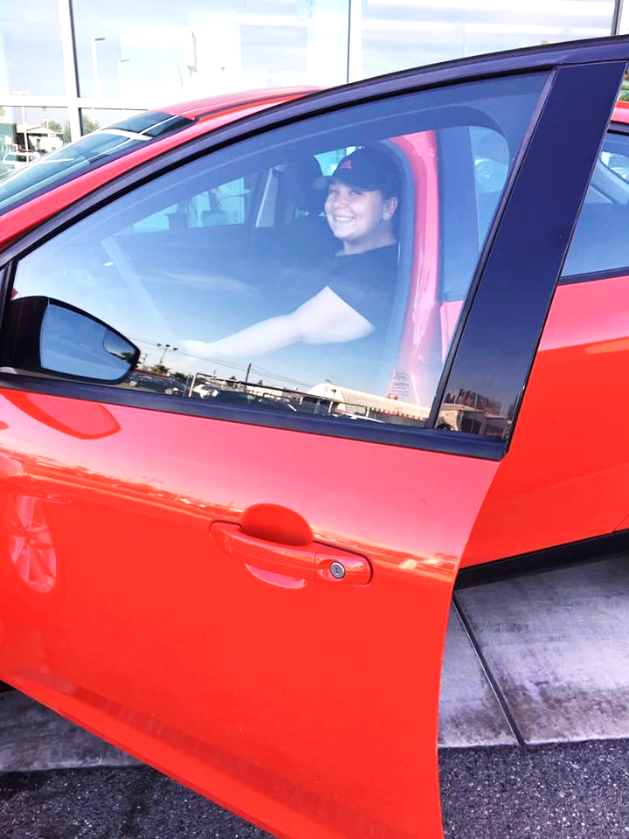
14

